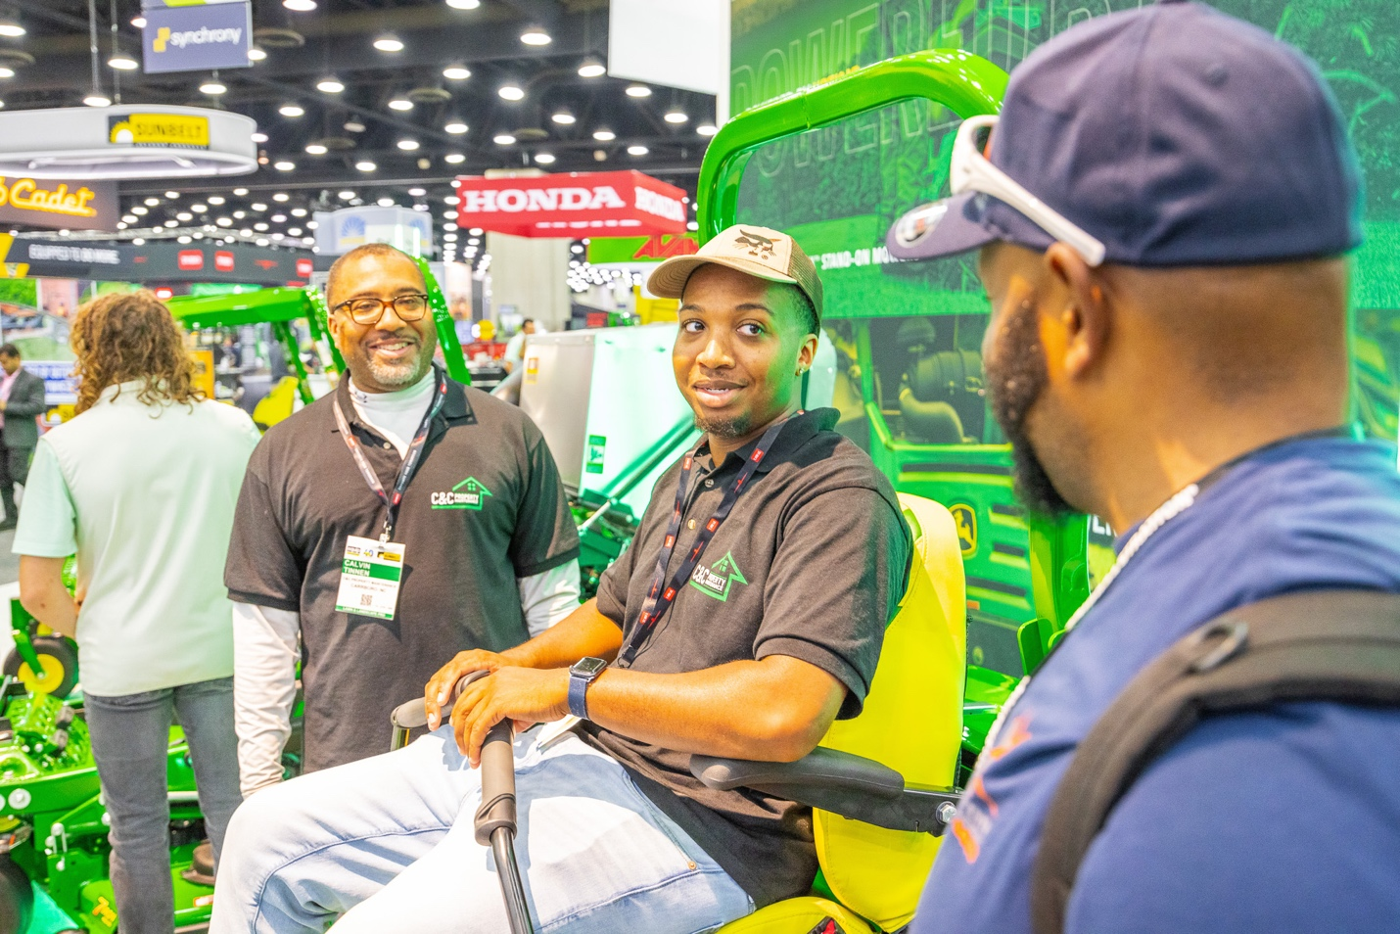
Spring Lawn Equipment: Keep Crews Safe with These 9 Tips
Spring is coming and commercial landscape contractors are gearing up for their busy season. The Outdoor Power Equipment Institute (OPEI), an international trade association representing outdoor power equipment, small engine, utility vehicle, golf car and personal transport vehicle manufacturers and suppliers, reminds landscapers to keep safety in mind as they head outside.
“Before you send your crews out to use a mower, trimmer, blower, power washer, chainsaw, pruner, portable generator or other piece of outdoor power equipment this season, it’s important they think safety first,” said Kris Kiser, President of OPEI. “Landscape companies have a busy season ahead, but they also need to take the time to do maintenance to ensure their equipment operates safely and is ready to get the job done all season long.”
Here are tips to help ensure landscape crews are safe:
Read the owner’s manual. Each crew member should be reminded to follow all guidelines for the outdoor power equipment and familiarize themselves with the controls. Review how to shut on, shut off, and use the equipment safely – especially with new team members. Manuals are available online and in many languages to ensure everyone is working from the same set of instructions.
Inspect equipment. Check the air filter, oil level and the gasoline tank. Also check for loose belts and missing or damaged parts. Ensure all safety guards are in place. Replace any parts needed or take the equipment to a qualified service representative for servicing. If using electric equipment, make sure batteries are in good working order, and not cracked or damaged.
Make sure all safety features are operable. Do not disable or modify manufacturer-installed safety equipment. Be sure that you review this with your work crews and check equipment when it returns from a work site.
Review equipment with your work crews before the season gets rolling. Make sure all your workers understand the safety features of the equipment they are using, and that they are following manufacturer guidelines and on-product messages for safe operation. Do spot safety checks on job sites, and incorporate safety checks into your morning roll-out.

Protect your power by only using E10 or less fuel in gasoline-powered outdoor power equipment. With today’s higher ethanol content fuels, most manufacturers are recommending a fuel stabilizer be used, especially if you don’t use up all the gas purchased right away. Some gas stations may offer 15 percent ethanol (E15) gas or higher ethanol fuel blends, but any fuel that has more than 10 percent ethanol can damage, and is illegal to use, in small engine equipment not designed for it.
Store fuel safely. Label your fuel can with the date of purchase and ethanol content of the fuel. Never put “old” gas in the outdoor power equipment. If you don’t know the date of purchase, dispose safely of the fuel in the can and buy fresh fuel. Always store fuel out of the reach of children or pets and in approved containers. Fuel should never sit in the gas tank for more than 30 days as it may starting or running problems or damage the equipment.
For battery-powered equipment, recharge your equipment only with the charger specified by the manufacturer. A charger that is suitable for one type of battery pack may create a risk of fire when used with another battery pack. Follow all charging instructions and do not charge the battery pack or tool outside the temperature range specified in the instructions.
Store batteries safely. When the battery pack is not in use, keep it away from other metal objects, like paper clips, coins, keys, nails, screws or other small metal items that can make a connection from one terminal to another. Storing the battery terminals together may cause burns or a fire.
Clean your equipment and store it in a dry place. Remove any dirt, oil or grass. Clean equipment will run more efficiently and last longer. Never store your equipment in a place that is damp or wet.
To learn more, go to www.opei.org. For further information on safe fueling, go to www.LookBeforeYouPump.com.
About OPEI
OPEI is an international trade association representing manufacturers and suppliers of power equipment, small engines, battery power systems, portable generators, utility and personal transport vehicles, and golf cars. OPEI is the advocacy voice of the industry, and a recognized Standards Development Organization for the American National Standards Institute (ANSI) and active internationally through the International Organization for Standardization (ISO), and the International Electrotechnical Commission (IEC) in the development of safety and performance standards. OPEI owns Equip Exposition, the international landscape, outdoor living and equipment exposition, and administers the TurfMutt Foundation, which directs the environmental education program, TurfMutt. OPEI-Canada represents members on a host of issues, including recycling, emissions and other regulatory developments across the Canadian provinces.
