Distracted Driving

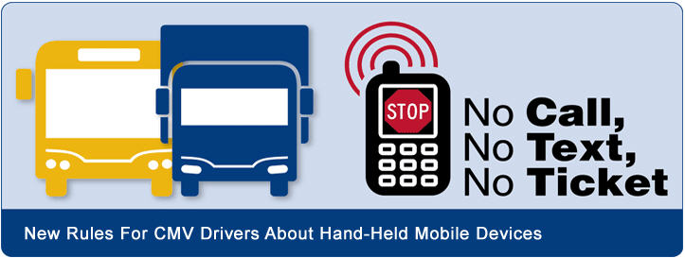

What You Need to Know

New texting and mobile phone restrictions for commercial motor vehicle (CMV) drivers
The FMCSA and the Pipeline and Hazardous Materials Safety Administration (PHMSA) have published rules specifically prohibiting interstate truck and bus drivers and drivers who transport placardable quantities of hazardous materials from texting or using hand-held mobile phones while operating their vehicles. The joint rules are the latest actions by the U.S. Department of Transportation to end distracted driving. Violations can result in fines and/or driver disqualifications and will impact a motor carrier’s and/or driver’s Safety Measurement System (SMS) results.

No texting while driving
CMV drivers are prohibited from texting while driving. So what qualifies as texting? Texting means manually entering alphanumeric text into, or reading text from, an electronic device. This includes, but is not limited to, short message service, e-mailing, instant messaging, a command or request to access a Web page, or pressing more than a single button to initiate or terminate a voice communication using a mobile phone or engaging in any other form of electronic text retrieval or entry, for present or future communication. (Click here for final rule).

Do not type or read a text message while driving a CMV!

Use of mobile phones is restricted for CMV drivers
This rule restricts a CMV driver from reaching for or holding a mobile phone to conduct a voice communication, as well as dialing by pressing more than a single button. CMV drivers who use a mobile phone while driving can only operate a hands-free phone located in close proximity. In short, the rule prohibits unsafely reaching for a device, holding a mobile phone, or pressing multiple buttons.

How can drivers use a mobile phone and still obey the rules?
- Locate the mobile phone so it is operable by the driver while restrained by properly adjusted safety belts.
- Utilize an earpiece or the speaker phone function.
- Use voice-activated or one-button touch features to initiate, answer, or terminate a call.
What happens if a driver is caught using a hand-held phone or texting while driving?
The rule imposes sanctions for driver offenses, including civil penalties up to $2,750 and driver disqualification for multiple offenses. Motor carriers are also prohibited from requiring or allowing their drivers to text or use a hand-held mobile phone while driving and may be subject to civil penalties up to $11,000. Violations will impact SMS results. Texting and calling on a hand-held phone carry the maximum violation severity weighting in SMS!

What are the risks?
Besides penalties and possible driver disqualification, recent research shows that the odds of being involved in a safety-critical event (e.g., crash, near-crash, unintentional lane deviation) are 23.2 times greater for CMV drivers who text while driving than for those who do not. Texting drivers took their eyes off the road for an average of 4.6 seconds. At 55 mph, this equates to a driver traveling the approximate length of a football field — without looking at the roadway! For CMV drivers who dial a mobile phone while driving, the odds of being involved in a safety-critical event are six times greater than for those who do not. Why take chances?
Bottom Line: Using a hand held device while driving is a serious traffic violation that could result in a driver disqualification.

No call, no text, no ticket!
Last updated: Monday, December 30, 2013

